МИНИСТЕРСТВО НАУКИ И ВЫСШЕГО ОБРАЗОВАНИЯ   
РОССИЙСКОЙ ФЕДЕРАЦИИ

ФЕДЕРАЛЬНОЕ ГОСУДАРСТВЕННОЕ БЮДЖЕТНОЕ ОБРАЗОВАТЕЛЬНОЕ УЧРЕЖДЕНИЕ ВЫСШЕГО ОБРАЗОВАНИЯ

**«БЕЛГОРОДСКИЙ ГОСУДАРСТВЕННЫЙ**

**ТЕХНОЛОГИЧЕСКИЙ УНИВЕРСИТЕТ им. В. Г. ШУХОВА»**

**(БГТУ им. В.Г. Шухова)**

Кафедра программного обеспечения вычислительной техники и автоматизированных систем

Лабораторная работа №1

по дисциплине «Технологии Web-программирования»

тема: «HTML. Разработка макетов и верстка шаблонов web-приложения с помощью языков HTML и CSS»

Выполнил: ст. группы ВТ-42

Черных Артём Вячеславович

Проверил: Картамышев С.В.

Белгород 2021 г.

**Цель работы:** изучить основы работы протокола передачи гипертекста HTTP. Изучить основы разметки страниц с помощью языка HTML. Изучить основы вёрстки страниц, адаптированных под различные устройства. Изучить основы работы задания стилей для разметки страницы с помощью языка CSS. Разработать макеты и «сверстать» страницы для web-приложения.

**Фреймворк**

В качестве фреймворка был выбран Bootstrap версии 5.

**Внешний вид страниц**

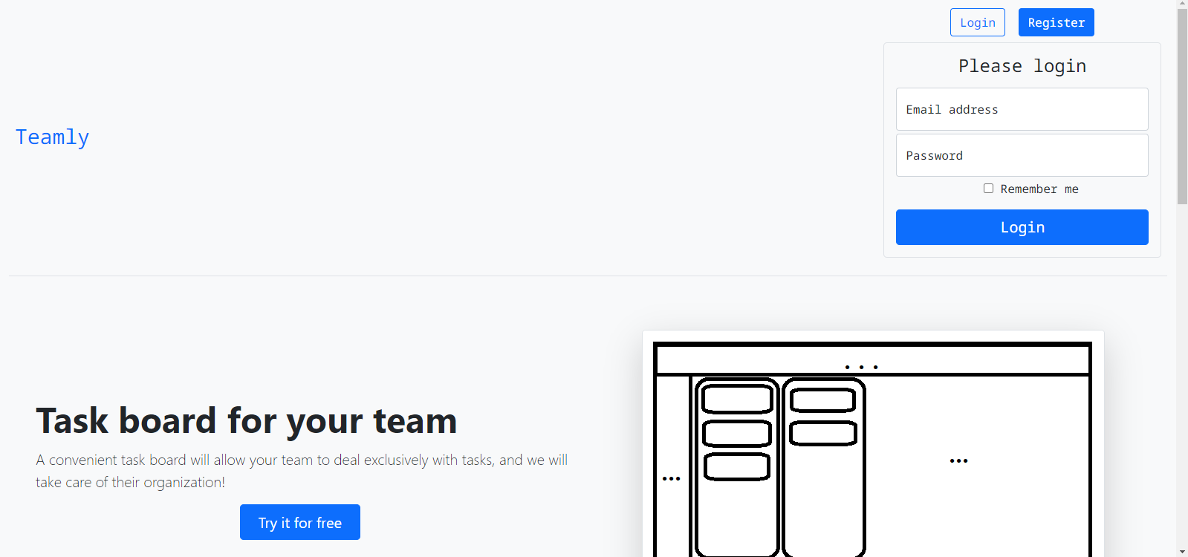

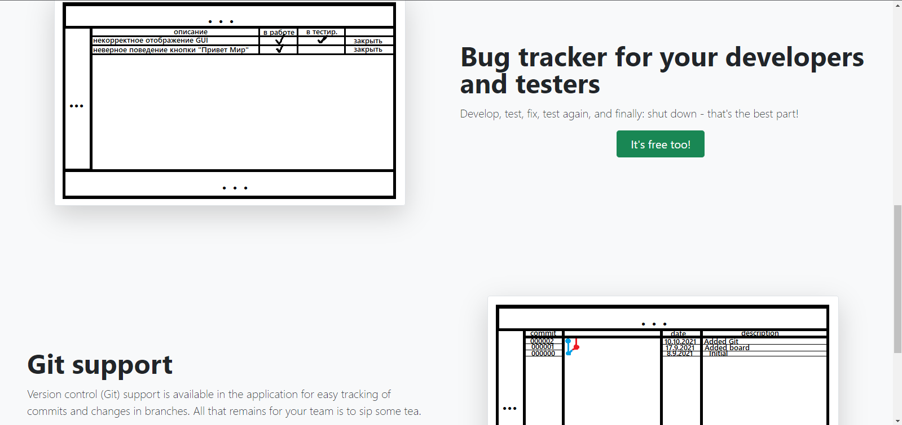

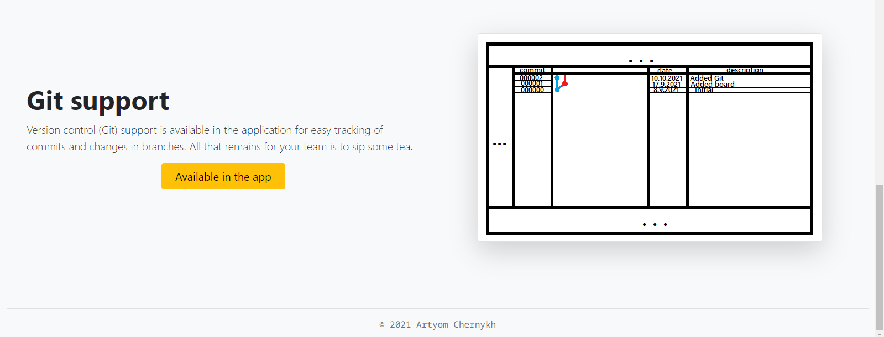

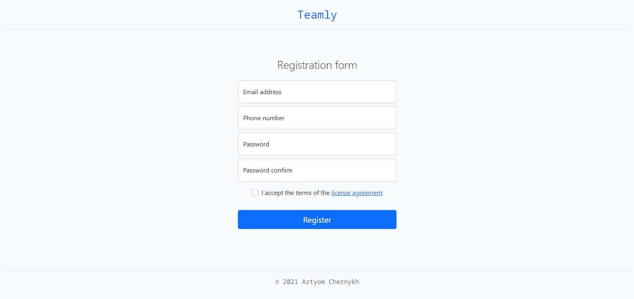

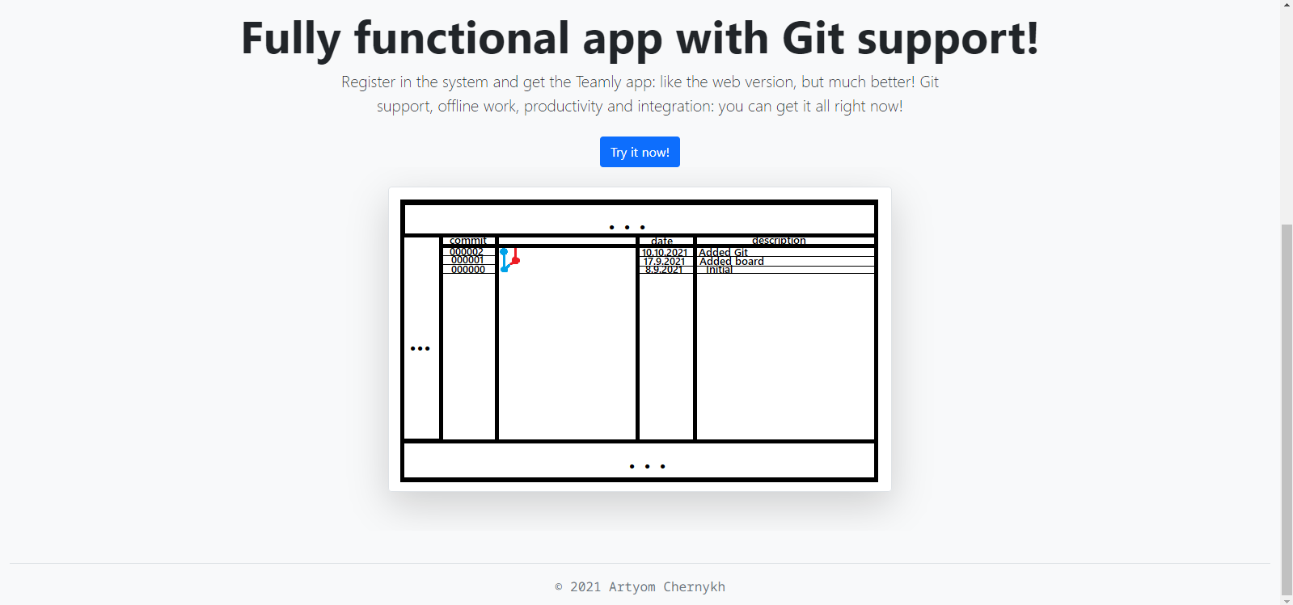

**Приложение**

**index.html**

<!DOCTYPE html>

<**html** lang="en">

<**head**>

<**meta** charset="UTF-8">

<**title**>Teamly</**title**>

<**link** rel="preconnect" href="https://fonts.googleapis.com">

<**link** rel="preconnect" href="https://fonts.gstatic.com" crossorigin>

<**link** href="https://fonts.googleapis.com/css2?family=Noto+Sans+Mono:wght@100;200;300;400;500;600;700;800;900&display=swap" rel="stylesheet">

<**link** href="css/bootstrap.css" rel="stylesheet">

<**link** href="css/bootstrap-grid.css" rel="stylesheet">

<**link** href="css/site.css" rel="stylesheet">

</**head**>

<**body** class="bg-light">

<!-- HEADER -->

<**div** class="container-fluid">

<**header** class="d-flex flex-wrap align-items-center justify-content-center justify-content-md-between py-3 mb-4 border-bottom">

<!-- TITLE HEADER -->

<**div** class="col-12 col-md-auto mb-2 justify-content-center mb-md-0">

<**a** href="index.html" class="px-2 fs-3 text-decoration-none">Teamly</**a**>

</**div**>

<!-- AUTH BLOCK -->

<**div** class="col-md-3 text-center">

<**button** type="button" class="btn btn-outline-primary me-2" onclick="toggleLoginBlock()">Login</**button**>

<**a** href="register.html" class="btn btn-primary">Register</**a**>

<!-- LOGIN BLOCK -->

<**div** class="login rounded-3 border text-center p-3 m-2">

<**form**>

<**h1** class="h4 mb-3 fw-normal">Please login</**h1**>

<!-- EMAIL -->

<**div** class="form-floating mb-1">

<**input** type="email" class="form-control" id="emailInput" placeholder="name@example.com" required>

<**label** for="emailInput">Email address</**label**>

</**div**>

<!-- PASSWORD -->

<**div** class="form-floating mb-1">

<**input** type="password" class="form-control" id="passwordInput" placeholder="Password" required>

<**label** for="passwordInput">Password</**label**>

</**div**>

<!-- REMEMBER ME -->

<**div** class="form-check mb-3">

<**label**>

<**input** type="checkbox" value="remember-me"> Remember me

</**label**>

</**div**>

<**button** class="w-100 btn btn-lg btn-primary" type="submit">Login</**button**>

</**form**>

</**div**>

</**div**>

</**header**>

</**div**>

<!-- MAIN -->

<**main** class="d-flex flex-row justify-content-between">

<!-- MAIN BLOCK -->

<**div** class="mx-5">

<!-- TASK BOARD FEATURE -->

<**div** class="row flex-lg-row-reverse align-items-center g-5 py-5">

<**div** class="col-10 col-sm-8 col-lg-6">

<**img** src="images/board.png" class="d-block mx-lg-auto img-fluid border rounded-3 shadow-lg" alt="Task board screenshot" loading="lazy">

</**div**>

<**div** class="col-lg-6">

<**h1** class="display-5 fw-bold lh-1 mb-3">Task board for your team</**h1**>

<**p** class="lead">A convenient task board will allow your team to deal exclusively with tasks, and we will take care of their organization!</**p**>

<**div** class="d-grid gap-1 d-md-flex justify-content-md-center">

<**a** href="register.html" class="btn btn-primary btn-lg px-4 me-md-2">

Try it for free

</**a**>

</**div**>

</**div**>

</**div**>

<!-- BUG TRACKER FEATURE -->

<**div** class="row flex-lg-row align-items-center g-5 py-5 my-3">

<**div** class="col-10 col-sm-8 col-lg-6">

<**img** src="images/bugtracker.png" class="d-block mx-lg-auto img-fluid border rounded-3 shadow-lg" alt="Bug tracker screenshot" loading="lazy">

</**div**>

<**div** class="col-lg-6">

<**h1** class="display-5 fw-bold lh-1 mb-3">Bug tracker for your developers and testers</**h1**>

<**p** class="lead">Develop, test, fix, test again, and finally: shut down - that's the best part!</**p**>

<**div** class="d-grid gap-1 d-md-flex justify-content-md-center">

<**a** href="register.html" class="btn btn-success btn-lg px-4 me-md-2">

It's free too!

</**a**>

</**div**>

</**div**>

</**div**>

<!-- GIT FEATURE -->

<**div** class="row flex-lg-row-reverse align-items-center g-5 py-5 my-3">

<**div** class="col-10 col-sm-8 col-lg-6">

<**img** src="images/git.png" class="d-block mx-lg-auto img-fluid border rounded-3 shadow-lg" alt="Git support screenshot" loading="lazy">

</**div**>

<**div** class="col-lg-6">

<**h1** class="display-5 fw-bold lh-1 mb-3">Git support</**h1**>

<**p** class="lead">Version control (Git) support is available in the application for easy tracking of commits and changes in branches. All that remains for your team is to sip some tea.</**p**>

<**div** class="d-grid gap-1 d-md-flex justify-content-md-center">

<**a** href="downloads.html" class="btn btn-warning btn-lg px-4 me-md-2">

Available in the app

</**a**>

</**div**>

</**div**>

</**div**>

</**div**>

</**main**>

<!-- FOOTER -->

<**div** class="container-fluid">

<**footer** class="pt-3 mt-4">

<**p** class="text-center text-muted border-top pt-3 mt-3">&copy; 2021 Artyom Chernykh</**p**>

</**footer**>

</**div**>

<**script** src="js/site.js"></**script**>

</**body**>

</**html**>

**register.html**

<!DOCTYPE html>

<**html** lang="en">

<**head**>

<**meta** charset="UTF-8">

<**title**>Welcome to Teamly!</**title**>

<**link** rel="preconnect" href="https://fonts.googleapis.com">

<**link** rel="preconnect" href="https://fonts.gstatic.com" crossorigin>

<**link** href="https://fonts.googleapis.com/css2?family=Noto+Sans+Mono:wght@100;200;300;400;500;600;700;800;900&display=swap" rel="stylesheet">

<**link** href="css/bootstrap.css" rel="stylesheet">

<**link** href="css/bootstrap-grid.css" rel="stylesheet">

<**link** href="css/site.css" rel="stylesheet">

</**head**>

<**body** class="bg-light">

<!-- HEADER -->

<**div** class="container-fluid">

<**header** class="align-items-center justify-content-center justify-content-md-between py-3 mb-4 border-bottom text-center">

<!-- TITLE HEADER -->

<**div** class="col-12 col-md-auto mb-2 justify-content-center mb-md-0">

<**a** href="index.html" class="px-2 fs-3 text-decoration-none">Teamly</**a**>

</**div**>

</**header**>

</**div**>

<!-- MAIN -->

<**main** class="text-center py-5 m-auto w-25" style="display: block">

<**form**>

<**h1** class="h3 mb-4 fw-lighter">Registration form</**h1**>

<!-- EMAIL -->

<**div** title="Your email address" class="form-floating mb-2">

<**input** type="email" class="form-control" id="emailInput" placeholder="your_email@example.com" required>

<**label** for="emailInput">Email address</**label**>

</**div**>

<!-- PHONE NUMBER -->

<**div** title="Your phone is proof that you are a real person" class="form-floating mb-2">

<**input** type="tel" class="form-control" id="phoneNumber" placeholder="+0 (000) 000-00-00" required>

<**label** for="phoneNumber">Phone number</**label**>

</**div**>

<!-- PASSWORD -->

<**div** class="form-floating mb-2">

<**input** type="password" class="form-control" id="passwordInput" placeholder="your_password" required>

<**label** for="passwordInput">Password</**label**>

</**div**>

<!-- PASSWORD CONFIRM -->

<**div** class="form-floating mb-3">

<**input** type="password" class="form-control" id="passwordConfirmInput" placeholder="your_password" required>

<**label** for="passwordConfirmInput">Password confirm</**label**>

</**div**>

<!-- LICENSE AGREEMENT -->

<**div** class="form-check mt-3 mb-3">

<**label**>

<**input** type="checkbox" class="form-check-input" value="remember-me" required>

I accept the terms of the

<**a** href="license.html" class="link-primary" >license agreement</**a**>

</**label**>

</**div**>

<**button** type="submit" class="btn btn-lg btn-primary mt-3 w-100">Register</**button**>

</**form**>

</**main**>

<!-- FOOTER -->

<**div** class="container-fluid">

<**footer** class="pt-3 mt-4">

<**p** class="text-center text-muted border-top pt-3 mt-3">&copy; 2021 Artyom Chernykh</**p**>

</**footer**>

</**div**>

<**script** src="js/site.js"></**script**>

</**body**>

</**html**>

**downloads.html**

<!DOCTYPE html>

<**html** lang="en">

<**head**>

<**meta** charset="UTF-8">

<**title**>Downloads</**title**>

<**link** rel="preconnect" href="https://fonts.googleapis.com">

<**link** rel="preconnect" href="https://fonts.gstatic.com" crossorigin>

<**link** href="https://fonts.googleapis.com/css2?family=Noto+Sans+Mono:wght@100;200;300;400;500;600;700;800;900&display=swap" rel="stylesheet">

<**link** href="css/bootstrap.css" rel="stylesheet">

<**link** href="css/bootstrap-grid.css" rel="stylesheet">

<**link** href="css/site.css" rel="stylesheet">

</**head**>

<**body** class="bg-light">

<!-- HEADER -->

<**div** class="container-fluid">

<**header** class="d-flex flex-wrap align-items-center justify-content-center justify-content-md-between py-3 mb-4 border-bottom">

<!-- TITLE HEADER -->

<**div** class="col-12 col-md-auto mb-2 justify-content-center mb-md-0">

<**a** href="index.html" class="px-2 fs-3 text-decoration-none">Teamly</**a**>

</**div**>

<!-- AUTH BLOCK -->

<**div** class="col-md-3 text-center">

<**button** type="button" class="btn btn-outline-primary me-2" onclick="toggleLoginBlock()">Login</**button**>

<**a** href="register.html" class="btn btn-primary">Register</**a**>

<!-- LOGIN BLOCK -->

<**div** class="login rounded-3 border text-center p-3 m-2">

<**form**>

<**h1** class="h4 mb-3 fw-normal">Please login</**h1**>

<!-- EMAIL -->

<**div** class="form-floating mb-1">

<**input** type="email" class="form-control" id="emailInput" placeholder="name@example.com" required>

<**label** for="emailInput">Email address</**label**>

</**div**>

<!-- PASSWORD -->

<**div** class="form-floating mb-1">

<**input** type="password" class="form-control" id="passwordInput" placeholder="Password" required>

<**label** for="passwordInput">Password</**label**>

</**div**>

<!-- REMEMBER ME -->

<**div** class="form-check mb-3">

<**label**>

<**input** type="checkbox" value="remember-me"> Remember me

</**label**>

</**div**>

<**button** class="w-100 btn btn-lg btn-primary" type="submit">Login</**button**>

</**form**>

</**div**>

</**div**>

</**header**>

</**div**>

<!-- MAIN -->

<**main**>

<!-- APP DESCRIPTION & DOWNLOAD -->

<**div** class="px-4 pt-5 my-2 text-center">

<**h1** class="display-4 fw-bold">Fully functional app with Git support!</**h1**>

<**div** class="col-lg-6 mx-auto">

<**p** class="lead mb-4">

Register in the system and get the Teamly app: like the web version, but much better!

Git support, offline work, productivity and integration: you can get it all right now!

</**p**>

<**a** href="register.html" class="btn btn-primary">Try it now!</**a**>

</**div**>

<**div** class="overflow-hidden py-4">

<**div** class="container px-5">

<**img** src="images/git.png" class="img-fluid border rounded-3 shadow-lg mb-4" alt="App screenshot" loading="lazy">

</**div**>

</**div**>

</**div**>

</**main**>

<!-- FOOTER -->

<**div** class="container-fluid">

<**footer** class="pt-3">

<**p** class="text-center text-muted border-top pt-3 mt-3">&copy; 2021 Artyom Chernykh</**p**>

</**footer**>

</**div**>

<**script** src="js/site.js"></**script**>

</**body**>

</**html**>

**site.css**

**div** **header** {

**font-family**: 'Noto Sans Mono', monospace;

}

.login {

**visibility**: hidden;

}

**div** **footer** {

**font-family**: 'Noto Sans Mono', monospace;

}

**site.js**

**let** _loginBlockShowed = document.querySelector(".login").style.visibility === "visible"

**function** **toggleLoginBlock**()

{

_loginBlockShowed = !_loginBlockShowed

document.querySelector(".login").style.visibility = _loginBlockShowed ? "visible" : "hidden"

}